Assignment 12

Watch all the 10 NoSQL Videos posted in the Announcement.

Download and install MongoDB

Using MongoDB Compass create Database name it *yourlastnameFirstnameDB*

Create collection name it Contact List

Insert three document as in the screen shot, substitute my data with your own

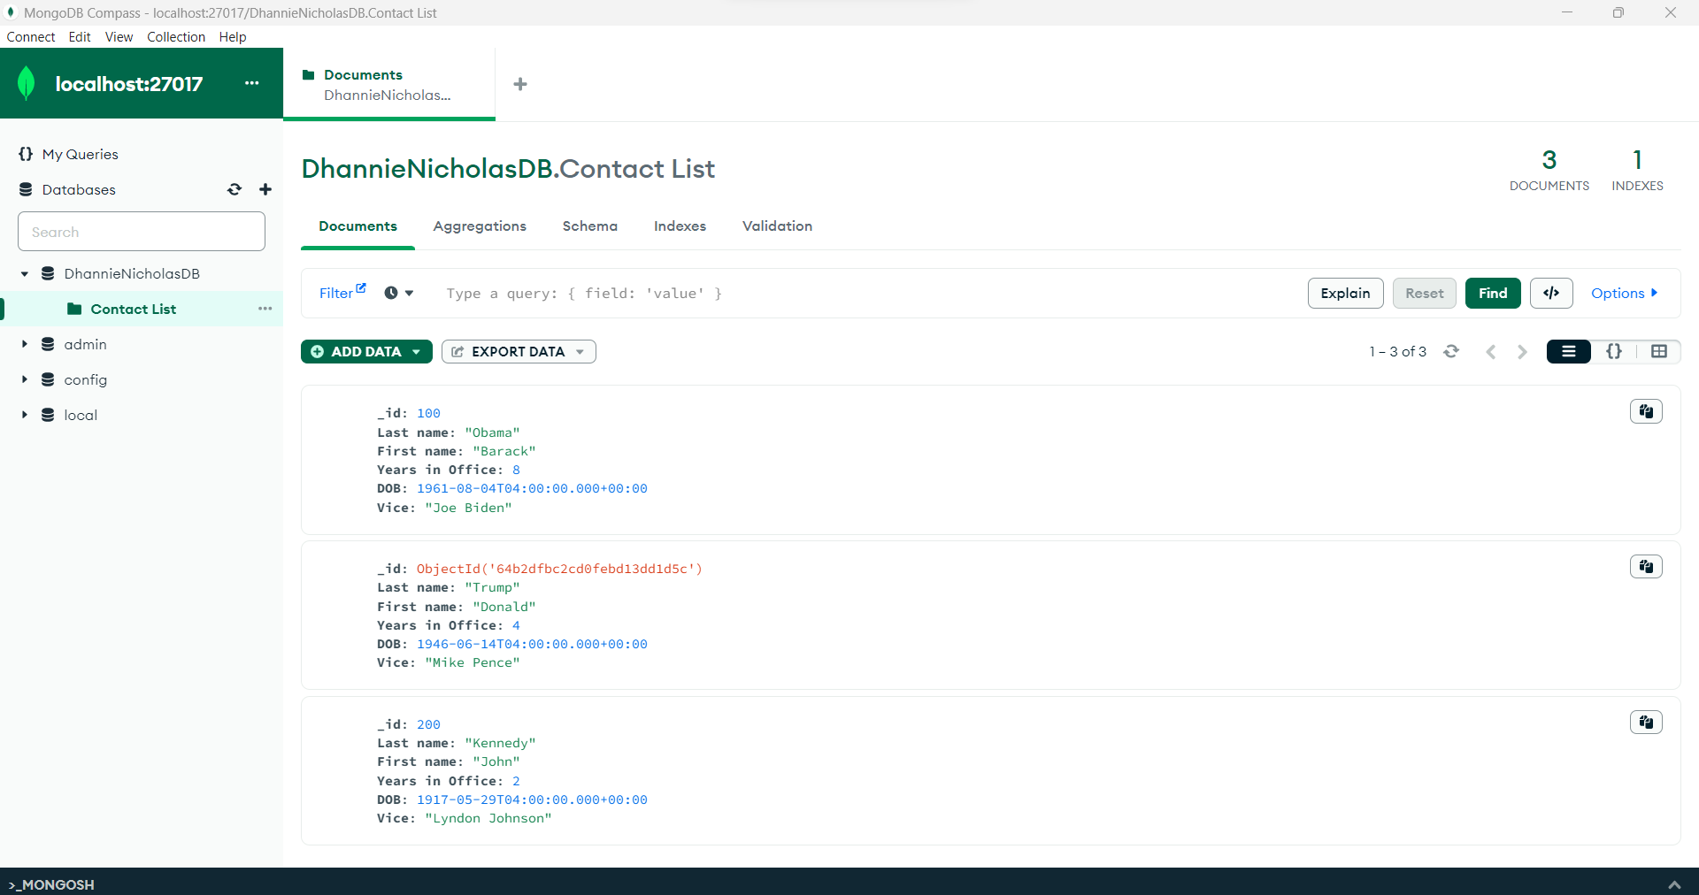

Take screen shot of your database using ***THIS*** document, remove my screen shot

Submit as usual by due date